Environmental Policy Statement

Usel was established in 1962 as a social enterprise supporting people with disabilities and health-related conditions into open employment in Northern Ireland. Our vision is to be the lead provider in helping people with disabilities gain employment. The company manufactures Bedding, Industrial Sewing and provides Circular Economy Recycling Services. Usel also operates a number of cafes under the Ability Café brand.
The company actively supports and practices good corporate and social responsibility. The company recognises that its activities impact on the environment, specifically in relation to waste management, energy consumption and air emissions.
Usel aims to conduct its business efficiently and at the same time delivering on its community and environmental responsibilities through effective management systems and programmes.
We are committed to:
- Complying with environmental legislation and with the regulatory authority, implementing relevant codes of practice and other requirements
- Protecting the environment and preventing pollution through operational best practice, emissions management, waste minimisation, efficient resource use, local conservation awareness and statutory authority liaison
- Setting objectives and targets to achieve continual environmental performance improvement
- Improving Energy Efficiency
- Communicating the Environmental Policy and the Environmental Management System to our employees and those working on our behalf and providing appropriate training
- Making our Environmental Policy publicly available
The company is committed to the ongoing improvement of the Environmental Management System that is certified to ISO 14001:2015. Usel has established and reviews specific measurable objectives through Environmental Objectives and Targets. Usel involves staff in meeting these objectives.
The Business Improvement Manager is responsible for ensuring the Environmental Management System is adequately implemented and maintained, supported by the Chief Executive and the Management Team.
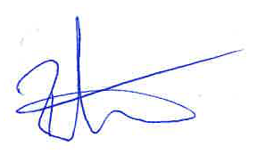
Chief Executive
September 2020

